Weekend of 08/16/2025-08/17/2025:
Attendance: 101 & Contributions to the General Fund: $8906
Thank you for your generosity!
Sunday, August 24, 2025
Adult Bible Study Class 8:30 AM - 9:30 AM Location: Education Room
Holy Donut Holes Fellowship 9:00 AM - 9:30 AM Location: Narthex
Blessing of the Backpacks 9:30 AM - 10:30 AM Location: Sanctuary
Worship Service 9:30 AM - 10:30 AM Location: Sanctuary
Choir Meeting 10:30 AM - 11:30 AM Location: Music Room
Pickleball (Peter, Paul & Pickleball) 4:00 PM - 6:00 PM Location: Family Life Center
NA Meeting 7:30 PM - 8:30 PM Location: Activity Center Monday, August 25, 2025
Staff Meeting 9:30 AM - 10:30 AM Location: Church Office Neighbor Helping Neighbor 1:00 PM - 2:00 PM Location: Activity Center Almost Free Shop 2:00 PM - 5:00 PM Location: Annex
Beginners Adult Pickleball 5:00 PM - 7:00 PM Location: Family Life Center Trustees Meeting 6:30 PM - 7:30 PM Location: Library
Tuesday, August 26, 2025
Almost Free Shop 9:00 AM - 12:00 PM Location: Annex
Alcoholics Anonymous (AA) Meeting 7:30 PM - 8:30 PM Location: Activity Center
Wednesday, August 27, 2025
WINGS 12:00 PM - 1:00 PM Location: Fellowship Hall Neighbor Helping Neighbor 1:00 PM - 3:00 PM Location: Activity Center MSPS Meet the Teacher Night 5:00 PM - 7:30 PM Location: Sanctuary;Preschool Free Community Meal 5:00 PM - 6:30 PM Location: Fellowship Hall
Thursday, August 28, 2025
Sarah Circle Meeting 1:30 PM - 2:30 PM Location: Fellowship Hall Pickleball (Peter, Paul & Pickleball) 5:00 PM - 7:00 PM Location: Family Life Center NA Meeting 7:30 PM - 8:30 PM Location: Activity Center
Friday, August 29, 2025
Almost Free Shop 9:00 AM - 4:00 PM Location: Annex Alcoholics Anonymous (AA) Meeting 12:00 PM - 2:00 PM Location: Activity Center
Haning Rehearsal 5:30 PM - 6:30 PM Location: Chapel
Narcotics Anonymous 6:00 PM - 7:00 PM Location: Activity Center
Saturday, August 30, 2025
Haning Reception 8:00 AM - 8:00 PM Location: Fellowship Hall/Kitc Haning Wedding 1:00 PM - 2:00 PM Location: Chapel
Chapel Worship Service 5:00 PM - 6:00 PM Location: Chapel

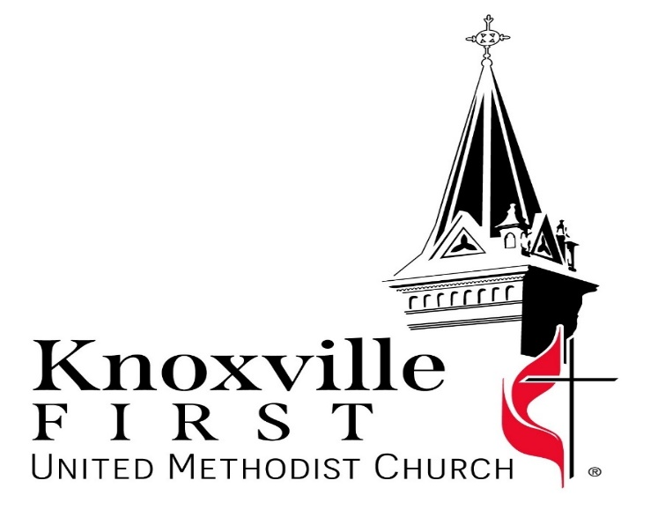

Our Mission: “Bring People to Christ”

Pastors: Jaeseong Lee & Brent Hanna
313 East Montgomery, Knoxville, IA 50138
Website: www.kfumc.com
Facebook: https://www.facebook.com/knoxvillemethodistchurch
Email: first@kfumc.com
Phone: 641-842-3712

Welcome to Our Visitors!

To all of you who are here for the first time today, we want to say thank you and Welcome!! We are so glad you are here! And we have a gift for you. Please stop by the Hospitality counter in the Narthex today before you leave to receive it, and enjoy some coffee, sweet treats and fellowship.

Knoxville First United Methodist Church
Sunday, August 24, 2025 at 9:30 a.m.

PRELUDE/ WORDS OF WELCOME/ANNOUNCEMENTS

+CALL TO WORSHIP

+HYMN: O For a Thousand Tongues to Sing (UMH #57) v. 1-3

AFFIRMATION: The Apostle’s Creed (UMH #881)

FIRST SCRIPTURE READING: Psalm 71-6

HYMN: Heal Us, Emmanuel, Hear Our Prayer (UMH #266) v. 1-3

PRAYER & LORD’S PRAYER (UMH #895)

HYMN: Heal Us, Emmanuel, Hear Our Prayer (UMH #266) v. 4&5

CHILDREN'S MESSAGE
BACKPACK BLESSINGS
KID’S SONG: I’ve Got the Joy, Joy, Joy v. 1 x2

OUR OFFERING

+DOXOLOGY (UMH #95)

SCRIPTURE: Luke 13:10-17(NRSVue)

MESSAGE: Compassion

+HYMN: Love Divine, All Loves Excelling (UMH #384)

+BENEDICTION

POSTLUDE

(+) Those who are able are invited to stand.
Attention All Singers: Choir Meeting After Service TODAY (August 24)
It's almost choir time! Think about joining our group. We sing the first Sunday of the month and make a joyful noise to the glory of God. There will be a brief meeting directly after church for Chancel Choir members in the choir room. If you have questions, call or text Christine Meyers (641) 891-7599. Musically yours, Christine Meyers, Director

Card Shower for Emma Poffenbarger’s 90th Birthday!
Emma will be celebrating her 90th birthday on August 31. Please send birthday wishes to her at 607 Cindy Lane, Knoxville, IA.

Free Community Meal, Wednesday, August 27th
Join us for a Free Community Meal on Wednesday, August 27, 2025, from 5:00 p.m. to 6:30 p.m. Enjoy a delicious Baked Potato Bar with various toppings, creamy Mac and Cheese, and freshly baked Cookies, along with refreshing Drinks. Everyone is welcome at 313 E Montgomery in Knoxville. Come share a meal and connect with the community!
UWF General Meeting on September 4 at 6:00 PM
United Women in Faith will hold a general meeting on September 4 at 6:00 pm. The evening will include a light supper followed by a program presented by our district shepherd, Lori Ann Haight, who will portray the Women at the Well. We invite everyone to join us for a fun evening. If you are not part of a circle and wish to join, please feel welcome.

Rally Day Worship With Potluck: Sunday, September 7th at 9:30 AM
Join us for a special outdoor worship on the church lawn, followed by a potluck lunch in the Fellowship Hall (church lower level).

Worship Service (Front Lawn): Enjoy uplifting music with a brass ensemble, along with a mix of contemporary and traditional songs to inspire and uplift everyone! Please remember to bring your lawn chairs.

Potluck Lunch (Fellowship Hall): After the service, we will gather indoors for a potluck lunch. You are encouraged to bring your favorite dish to share. Please drop off your dish in Fellowship Hall before the start of the worship service. Tableware, cutlery, and drinks will be provided.

Everyone is invited, and we encourage you to invite friends and family for a morning filled with faith, fellowship, and community spirit. We look forward to seeing you there!!

