Sunday, November 16, 2025
Adult Bible Study Class 8:30 AM - 9:30 AM Location: Education Room
Breeze Sign Up 8:45 AM - 9:15 AM & 10:30 AM 1-11:00 AM Location: Narthex
Practice for Children's Christmas 8:45 AM - 9:15 AM Location: Kids Kingdom
Holy Donut Holes Fellowship Time 9:00 AM - 9:30 AM Location: Narthex
Worship Service 9:30 AM - 10:30 AM Location: Sanctuary
Children's Church 10:00 AM - 10:30 AM Location: Kid's Kingdom
Pickleball (Peter, Paul & Pickleball) 4:00 PM - 6:00 PM Location: Family Life Center
Youth Group 5:00 PM - 7:00 PM Location: Youth Room
NA Meeting 7:30 PM - 8:30 PM Location: Activity Center
Monday, November 17, 2025
Monday Morning Panthers 7:30 AM - 9:30 AM Location: Fellowship Hall; KK
Staff Meeting 11:15 AM - 12:15 PM Location: Church Office
Neighbor Helping Neighbor 1:00 PM - 2:00 PM Location: Activity Center
Almost Free Shop 2:00 PM - 5:00 PM Location: Annex
Beginners Adult Pickleball 5:00 PM - 7:00 PM Location: Family Life Center
Girl Scouts 5:00 PM - 7:00 PM Location: Kids Kingdom
Finance Committee Meeting 5:30 PM - 6:30 PM Location: Fellowship Hall
SPRC 6:30 PM - 7:30 PM Location: Library
Tuesday, November 18, 2025
Almost Free Shop 9:00 AM - 12:00 PM Location: Annex
Knox Com Chorus Rehearsal 6:30 PM - 9:00 PM Location: Sanctuary
Alcoholics Anonymous (AA) Mtg 7:30 PM - 8:30 PM Location: Activity Center
Wednesday, November 19, 2025
WINGS 12:00 PM - 1:00 PM Location: Fellowship Hall
Neighbor Helping Neighbor 1:00 PM - 3:00 PM Location: Activity Center
Piano Tuning 3:00 PM - 7:00 PM Location: Sanctuary
Pathfinders 3:30 PM - 5:00 PM Location: Kids Kingdom
Confirmation 7:00 PM - 8:15 PM Location: Fellowship Hall
Thursday, November 20, 2025
Adult Bible Study Class Lunch Mtg 11:00 AM - 1:30 PM Location: Education Room
Pickleball (Peter, Paul & Pickleball) 5:00 PM - 7:00 PM Location: Family Life Center
NA Meeting 7:30 PM - 8:30 PM Location: Activity Center
Friday, November 21, 2025
Almost Free Shop 9:00 AM - 4:00 PM Location: Annex
Alcoholics Anonymous (AA) Mtg 12:00 PM - 2:00 PM Location: Activity Center
Narcotics Anonymous 6:00 PM - 7:00 PM Location: Activity Center
Saturday, November 22, 2025
Decorate Sanctuary for Christmas/Advent 9:00 AM – 11:00 AM Location: Sanctuary
Chapel Worship Service 5:00 PM - 6:00 PM Location: Chapel

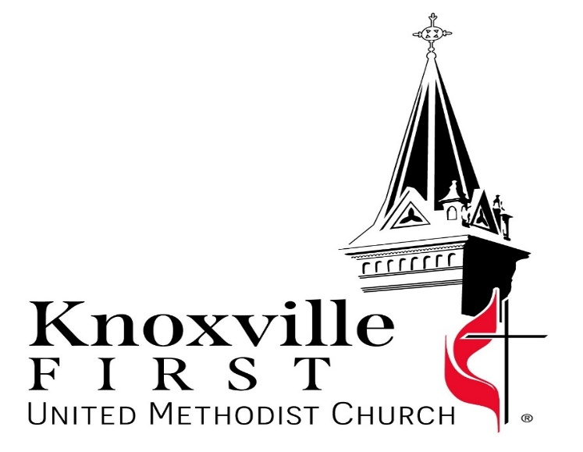

Our Mission: “Bring People to Christ”

Pastors: Jaeseong Lee & Brent Hanna
313 East Montgomery, Knoxville, IA 50138
Website: www.kfumc.com
Facebook: https://www.facebook.com/knoxvillemethodistchurch
Email: first@kfumc.com
Phone: 641-842-3712

Welcome to Our Visitors!

To all of you who are here for the first time today, we want to say thank you and Welcome!! We are so glad you are here! And we have a gift for you. Please stop by the Hospitality counter in the Narthex today before you leave to receive it, and enjoy some coffee, sweet treats and fellowship.

Knoxville First United Methodist Church
Sunday, November 16, 2025 at 9:30 a.m.

PRELUDE/ WORDS OF WELCOME/ANNOUNCEMENTS

+CALL TO WORSHIP Call to Worship (inspired by John 15:1-8)

+HYMN: Come, Thou Almighty King (UMH #61)

AFFIRMATION: The Apostle’s Creed (UMH #881)

FIRST SCRIPTURE READING: Isaiah 55:6-9 (CEB)

+HYMN: His Name Is Wonderful (UMH #174)

PRAYER & LORD’S PRAYER (UMH #895)

CHILDREN'S MESSAGE
KID’S SONG

UWF GIVING OF MISSION PINS

OUR OFFERING

+DOXOLOGY Hymn (UMH #95)

SCRIPTURE: John 15:1-17 (NRSVUE)

MESSAGE: Leaning In
Sermon Series: Called: Hearing and Responding to God's Voice

+HYMN: Leaning on the Everlasting Arms (UMH #133)

+BENEDICTION

POSTLUDE

(+) Those who are able are invited to stand.

Poinsettia Orders Due Today, Sunday, November 16.
Let's brighten our church together during this joyful Advent and Christmas season! You can honor or remember someone special by purchasing a beautiful poinsettia for just $13. Order forms are available in the Narthex and need to be submitted today. Thank you for helping us make the season extra special!

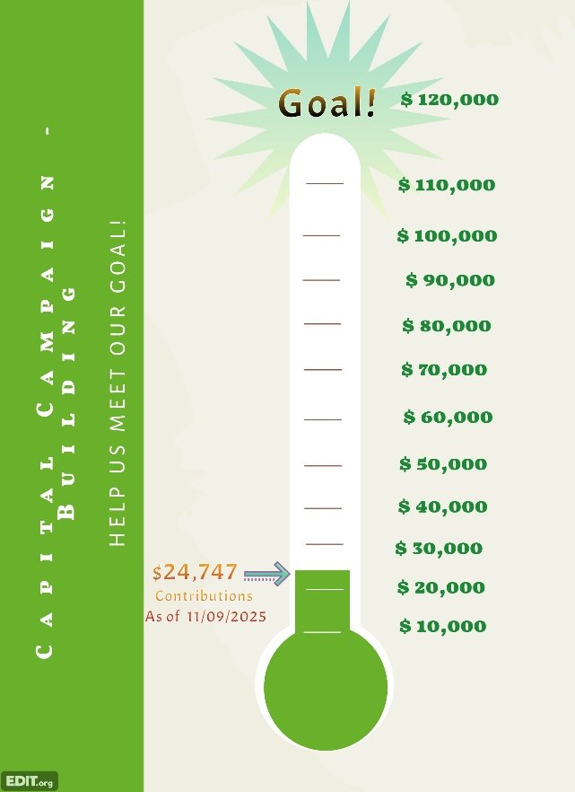
Youth Group Pumpkin Pie Fundraiser
The Living Way Youth is selling homemade pumpkin pies for Thanksgiving to support their trips and events. Each pie costs $15, and orders are due by November 19th. To order, email Lauren at lpetersen@kfumc.com or sign up in the Narthex. Pie pickup is on November 26th from 3:00 PM to 4:30 PM. Thank you for your support!
Help Decorate the Church
Join us to decorate the church for Advent on Saturday, November 22, from 9 AM to noon! Many hands make light work, and we typically finish in less than three hours.

2025 Capital Campaign: Building –


OUR GOAL IS TO RAISE $120,000
Ready to donate? Scan the QR code or contribute online through Breeze at https://kfumc.breezechms.com/give/online
or via your Breeze app. Select “Give to 123 Capital Campaign: Building 2025” as the fund in the first dropdown to make a one-time or recurring donation using your debit/credit card or ACH bank withdrawal.

Prefer to give by cash or check? Please write “Capital Campaign” in the memo line of your check or on your cash envelope.

